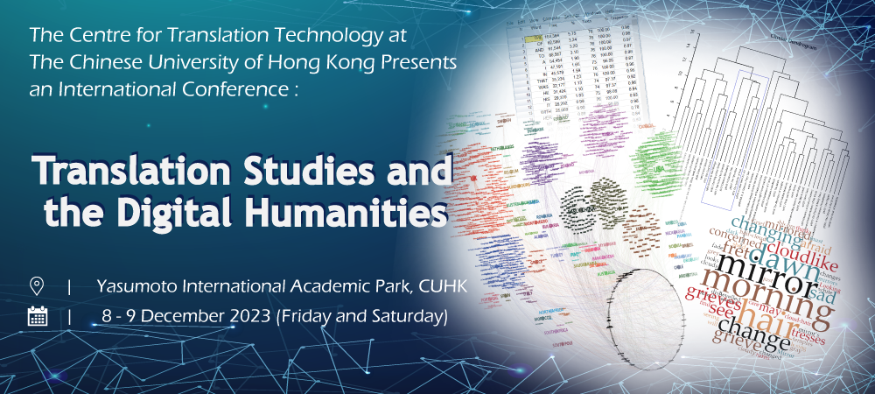
Translation Studies and Digital Humanities
Please send the completed form to dhintranslation@cuhk.edu.hk on or before 28 July 2023.

Personal Particulars
Name:
Title: Prof. Dr. Mr. Ms.
Correspondence Address:

Office/Mobile Telephone: | E-mail Address:
Affiliation
Name of Affiliated Institute:
Name of Affiliated Department:
Position Held (Please write “PhD/MPhil candidate” if you are a student):

Please Provide a Short Biography (No more than 250 words):

Presentation Details
Title of Paper:

Abstract (no more than 250 words):

